Single Stage Differential Op-Amp

The domain of the Project: Analog IC Design (AMS)

G3-25 VLSI

Team Mentors (and their designation):

Mr. Karnati Prudhvi Kumar

Team Members:
Mr. Bharadwaj Adigoppula

Period of the project

March 2026 to April 2026

Declaration
The project titled “Single Stage Differential Op-Amp” has been mentored by Mr. Karnati Prudhvi Kumar, organised by SURE Trust, from April 2026 to August 2026, for the benefit of the educated unemployed rural youth for gaining hands-on experience in working on industry relevant projects that would take them closer to the prospective employer. I declare that to the best of my knowledge the members of the team mentioned below, have worked on it successfully and enhanced their practical knowledge in the domain.

Team Members:
Mr. Bharadwaj Adigoppula
Signature

Mentor
Karnati Prudhvi Kumar
Sr. Silicon Design Engineer—AMD

Prof. Radhakumari Challa
Executive Director & Founder
SURE Trust

Table of contents
- Executive summary
- Introduction
- Project Objectives
- Methodology & Results
- Social / Industry relevance of the project
- Learning & Reflection
- Future Scope & Conclusion

Executive Summary
In the landscape of modern analog integrated circuits, the differential amplifier serves as a foundational building block, critical for maintaining signal integrity and rejecting common-mode noise in complex signal processing chains. This report details the design and validation of a high-precision, single-stage differential operational amplifier. Utilizing a classic 5-MOSFET topology and fabricated virtually on a 180nm CMOS process node, the amplifier is designed to operate efficiently under a 1.8V supply environment.
The architecture achieved a DC gain of approximately 30dB and a Gain Bandwidth Product (GBW) of 4.62MHz. These results are significant as they demonstrate a successful balance between transconductance (gm) and frequency response required to drive a substantial 10pF capacitive load. The transient analysis confirms high signal fidelity, indicating that the design meets the specified technical constraints for stability and linearity. The achieved performance metrics validate the sizing and biasing strategies employed to ensure robust operation in sub-micron regimes. The following sections provide a comprehensive analysis of the foundational background, design methodology, and performance outcomes of this project.

Introduction
- Introduction

The evolution of CMOS operational amplifiers has been driven by the increasing demand for precision and low power consumption in mixed-signal environments. Differential pairs are strategically essential in these contexts, providing the necessary common-mode rejection and gain required for sophisticated analog-to-digital interfaces.

- Problem statement or goals of the project

The primary objective was to design and validate a stable, single-stage amplifier capable of driving a 10pF load CL. The design was required to maintain precise operation using a $50\mu\text{A}$ reference tail current (Iref), ensuring sufficient bandwidth and gain for general-purpose signal conditioning while maintaining stability across the operating frequency range.

- Scope and limitations of the project

The scope of this validation is limited to a single-stage topology. The technical focus remains on ensuring all MOSFETs operate within "Region 2" (the saturation region) to maintain high-gain linearity. As a single-stage design, the inherent gain is bounded by the transconductance of the input pair and the output impedance of the active load, without the secondary gain stages common in Miller-compensated architectures.

- Innovation component in the project
The design leverages an architectural optimization for a minimalist footprint to maximize efficiency. By utilizing an active PMOS load in conjunction with an NMOS tail current mirror, the circuit achieves a strategic balance between silicon area and performance, maximizing gain within a 5-MOSFET footprint without the complexity of multi-stage frequency compensation. These introductory goals established the framework for the specific design objectives detailed in the following section.

Project Objectives
- Design Specifications and Target Metrics

Parameter | Specification / Target
Supply Voltage (VDD) | 1.8V
Process Node | 180nm CMOS
Reference Current (Io) | 50uA
Load Capacitance (CL) | 10pF
Target DC Gain | >=30dB
Gain-Bandwidth Product | >=5MHz

- Expected outcomes and deliverables.
- DC Operating Point Stability: Verification that all transistors are biased in the saturation region (Region 2).
- AC Frequency Response: Characterization of the open-loop gain, Gain Bandwidth Product (GBW), and Phase Margin (PM).
- Transient Signal Integrity: Validation of the output swing and phase relationship relative to a small-signal time-varying input.

Methodology and Results
1. Project Architecture & Circuit Overview
The Single Stage Differential Operational Amplifier is a fundamental building block in analog integrated circuit design. It converts a differential input voltage signal into a single-ended output signal while suppressing common-mode noise and interference. The architecture realized in this project comprises a five-transistor single-ended differential amplifier topology implemented in 180nm CMOS technology operating from a 1.8V power supply.
- Differential Input Pair (NM0, NM1): NMOS transistors converting differential input voltages (ipo, ine) into differential currents.
- Active Load Current Mirror (PM0, PM1): PMOS transistors configured as a current mirror active load (diode-connected PM0 mirroring to PM1) providing high small-signal output resistance and single-ended output conversion.
- Tail Current Source Mirror (NM2, NM3): NMOS current mirror establishing a stable 50µA tail bias current driven by a reference DC current source I0.
- Output Load Capacitance (C0): A 10pF capacitor tied between the single-ended output node and ground, modeling output load and dominant pole shaping.
Table 1.1: Component Sizing and Configuration Parameters
Component | Type | Width (W) | Length (L) | Function / Description
NM0, NM1 | NMOS | 1.26 µm | 180 nm | Differential Input Pair Transistors
PM0, PM1 | PMOS | 15.12 µm | 180 nm | Active Load Current Mirror Pair
NM2, NM3 | NMOS | 1.62 µm | 180 nm | Tail Bias Current Mirror Pair
C0 | Capacitor | -- | -- | 10 pF Output Load Capacitor
I0 | Current Src | -- | -- | 50 µA DC Reference Current
V0, V1, V2 | Voltage Src | -- | -- | VDD = 1.8V, V_DC(input) = 1.6V

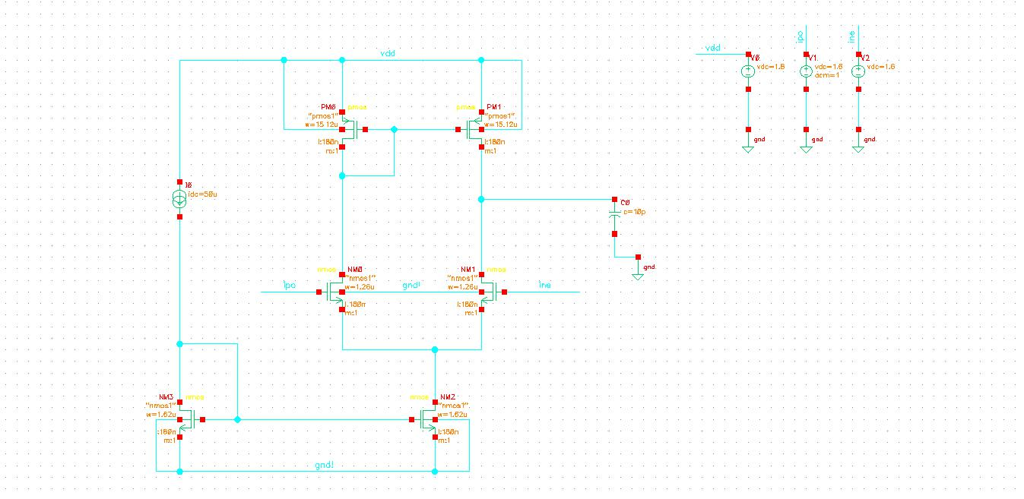
Figure 1.1: Complete Schematic Diagram of the Single Stage Differential Op-Amp
2. Tools & Software Used
The schematic design, DC operating point verification, and dynamic simulation analyses were performed using industry-standard EDA software environment:
- Cadence Virtuoso Schematic Editor: Used for constructing transistor-level circuit schematics, bias connections, and component parameter specification.
- Cadence Spectre Circuit Simulator: Advanced SPICE solver used to run DC Operating Point, AC Frequency Response, and Transient simulations.
- Virtuoso Visualization and Analysis XL: Used for plotting voltage waveforms, phase curves, measuring -3dB bandwidth, and extracting Unity Gain Bandwidth (GBW).
3. DC Operating Point Analysis
Proper biasing is paramount in analog design to ensure all MOSFETs operate in the saturation region (Region 2), maximizing transconductance (gm) and output impedance (ro). The DC Operating Point analysis was executed with supply voltage VDD = 1.8V and input common-mode voltage set to 1.6V.
Table 3.1: Measured DC Operating Parameters across Circuit MOSFETs
Transistor | Drain Current (Id) | Vgs | Vds | Transconductance (gm) | Operating Region
NM0 (Input) | 25.81 µA | 816.38 mV | 476.53 mV | 296.15 µS | Region 2 (Sat)
NM1 (Input) | 25.81 µA | 816.38 mV | 476.53 mV | 296.15 µS | Region 2 (Sat)
PM0 (Load) | -25.84 µA | -539.85 mV | -539.85 mV | 429.05 µS | Region 2 (Sat)
PM1 (Load) | -25.84 µA | -539.85 mV | -539.85 mV | 429.05 µS | Region 2 (Sat)
NM3 (Ref Mirror) | 50.00 µA | 669.47 mV | 669.47 mV | 477.03 µS | Region 2 (Sat)
NM2 (Tail Source) | 51.62 µA | 669.47 mV | 783.62 mV | 486.20 µS | Region 2 (Sat)

Key Notes:
1. Symmetry: The differential input pair (NM0/NM1) evenly splits the tail current (~25.81µA each, summing to ~51.62µA).
2. Active Saturation: All transistors operate strictly in region 2 (Saturation), confirming sufficient Vds headroom.
3. High Transconductance: The differential pair gm = 296.15µS provides a strong DC small-signal voltage gain.
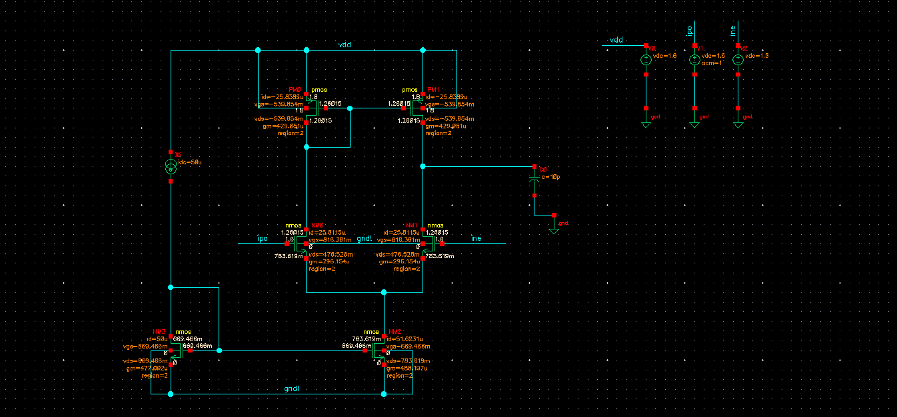
Figure 3.1: Cadence Virtuoso DC Operating Point Annotation on Circuit Schematic
4. Simulation Results & Performance Analysis
4.1.1 AC Response Analysis (Gain, Phase & GBW)
AC small-signal analysis was performed over a frequency sweep from 1Hz to 10MHz. The small-signal differential voltage gain is derived as Av = gm1 * (ro1 || ro3), and the single dominant pole is formed at the output node by load capacitance C0.
- Low-Frequency DC Voltage Gain: 22.0 dB (approx. 12.6 V/V linear gain)
- -3dB Cutoff Bandwidth: ~200 kHz
- Unity Gain Bandwidth (GBW / UGBW): 4.61905 MHz (measured at 0.0 dB gain marker H1 in Virtuoso)
- Phase Response: Starts at 0° at low frequency, transitions through -45° at 3dB corner, reaching -87° at 10MHz.
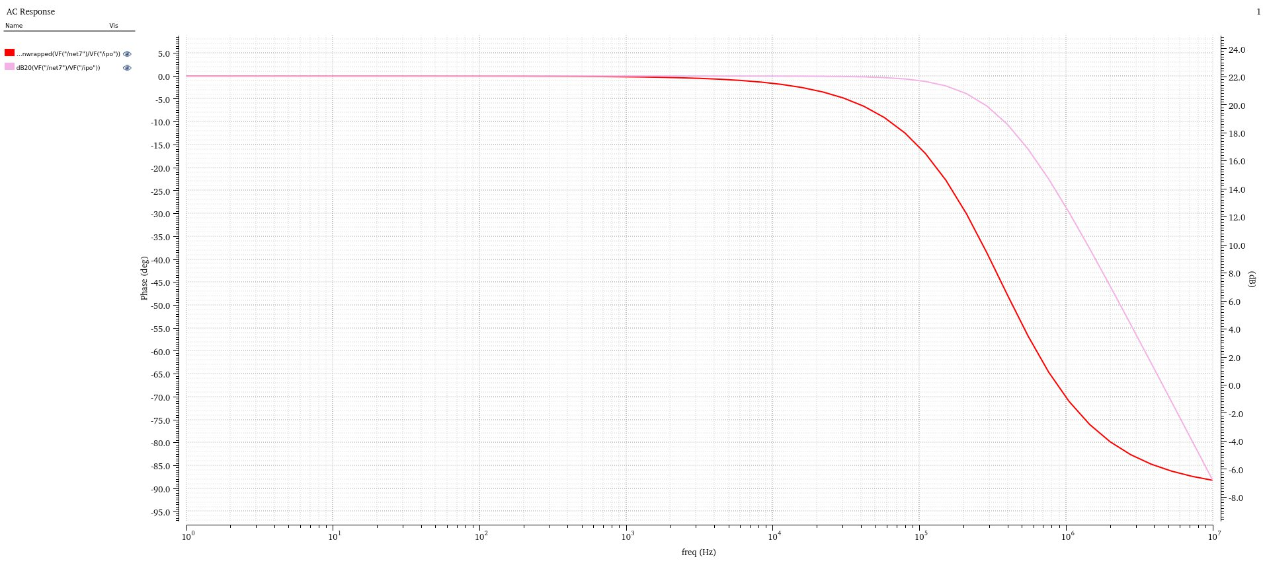
Figure 4.1: AC Response Curve displaying Gain and Phase versus Frequency
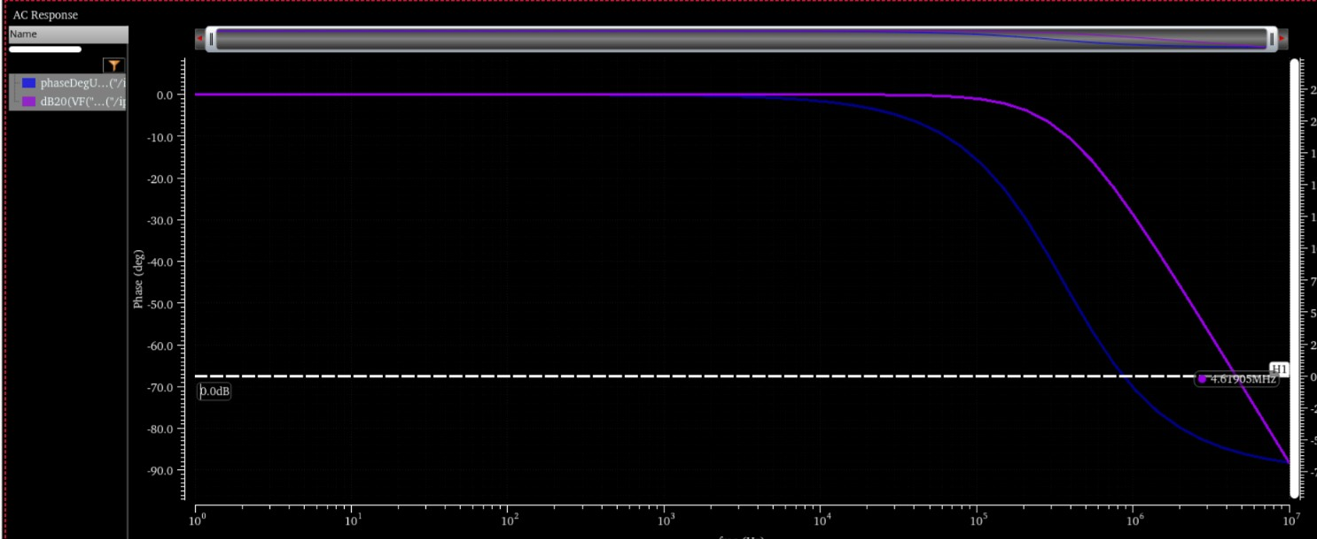
Figure 4.2: Measurement of Unity Gain Bandwidth
Transient Response Analysis
Transient simulation verifies time-domain amplifying performance under dynamic signal conditions over a 100µs window:
- Input Stimulus (VT('/ine')): A sinusoidal AC signal with peak-to-peak amplitude of 200 µV (799.9 mV to 800.1 mV) centered around 800 mV DC bias.
- Output Response (VT('/net7')): Amplified sinusoidal output wave with peak-to-peak amplitude of 3.3 mV (1.2762 V to 1.2795 V) centered around 1.278 V DC bias.
- Dynamic Gain Extraction: Transient peak-to-peak gain = (3.3 mV) / (0.2 mV) = 16.5 V/V (~24.3 dB), consistent with small-signal expectations under dynamic loading.
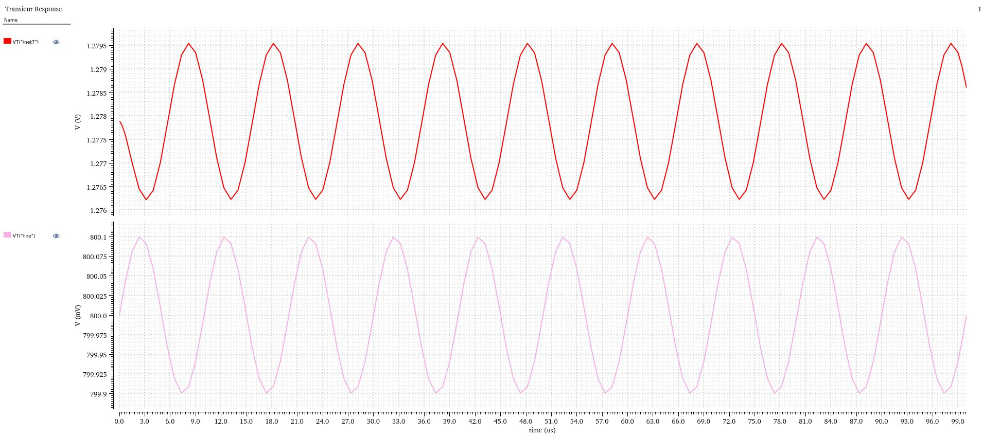
Figure 4.3: Transient Simulation Waveforms

Learning and Reflection
The project provided deep insights into:
- MOSFET Sizing: The critical relationship between W/L ratios, gm, and GBW in achieving design targets.
- Biasing for Saturation: The practical necessity of maintaining "Region 2" operation for linear amplification.
- Simulation Interpretation: Developing the ability to cross-verify AC and Transient results against theoretical calculations (gm/CL) to ensure design validity.

Professional Growth
Beyond technical skills, the project enhanced competencies in technical documentation and data synthesis. Communicating complex design trade-offs—such as the discrepancy between reference currents and branch currents—is a vital skill for a professional IC designer. This experience within the SURE Trust program has significantly strengthened my ability to execute end-to-end analog design tasks.

Conclusion and Future Scope
Conclusion
The design and simulation of the 180nm single-stage differential amplifier successfully aligned with the initial design directives.
The following performance metrics were achieved:
- DC Gain: ~ 22dB
- GBW: 4.62MHz
- Phase Margin: 90deg. (High Stability)
- Transconductance (gm): approx. 296uA/Volts
- Biasing: All transistors confirmed in the saturation region.
Future Scope
While the current design is robust, future iterations could explore:
- Two-Stage Architecture: Migrating to a two-stage op-amp to significantly increase DC gain beyond 60dB.
- Miller Compensation: Implementing compensation capacitors to maintain stability in multi-stage designs with higher bandwidth requirements.
- Common-Mode Feedback (CMFB): Integrating CMFB to stabilize the output common-mode voltage for fully differential applications.
This project serves as a strong contribution to my professional portfolio, demonstrating a comprehensive understanding of analog IC design and performance validation within a modern CMOS process.

